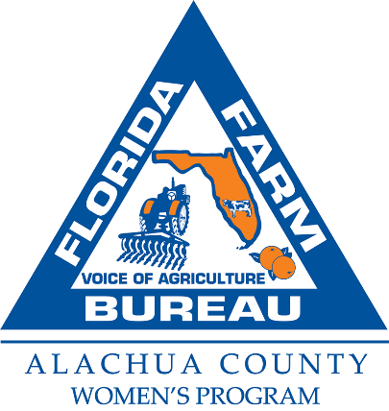

**2023 Alachua County Farm Bureau Education Mini-Grant Application**

The Alachua County Farm Bureau Mini Grant Program for Agriculture and Science related instruction for grades K-12. Each grant is up to $500.00. Grant recipients agree to submit a written report with photographs of the mini grant project upon its completion by May 15, 2024. Submitted photos may be published and submission serves as permission to publish photos containing students. Three Mini Grants will be awarded.

Please email the completed application by **October 20, 2023** to:

[peggi.justesen@ffbf.org](mailto:peggi.justesen@ffbf.org)

Or deliver or mail to: Alachua County Farm Bureau, 16206 NW 163rd Ln, Alachua, FL 32615

On a separate page please list:

What is the purpose of this project? This is the why or the goals of the project.

Description of the project. This is the how of the project. How will you complete the purpose/goals.

List at least 3 measurable outcomes of this project. Can be qualitative or quantitative.

Proposed budget to include item and cost of each item.

Learning objectives.

Teacher strategies, brief lesson plan

Your Name______________________________________________________

Your Email_______________________________________________________

School______________________________Subject______________________

School Address___________________________________________________

Phone Number________________________Grade Level__________________

Members of the Mini Grant Committee may request a visit to see your project.

If you have questions please call ACFB at 386-418-4008.