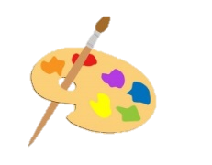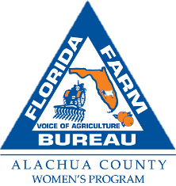

**Art Contest**

**Theme-Local Agriculture**

Alachua County Farm Bureau offers you the opportunity to be rewarded for your artistic skills and appreciation for local agriculture in Alachua County in its annual art contest.

**Contest Guidelines**

* Open to students in grades 1-12 in three categories: 1-5; 6-8; and 9-12.
* The first-place artist in each grade category will be awarded $125.00 and the winners’ schools will receive an art basket filled with art supplies.
* Acceptable media: Ink, pencil, oil, acrylic, crayon or watercolor. We do not have a category for graphic design creations, so all work must be created by hand.
* Paper or canvas should be no larger than 20” x 14”.
* Art work should be camera ready.
* Each piece should include the bottom part of thiscontest application completed legibly and carefully affixed to the back.
* The student must be willing to allow Alachua County Farm Bureau to reprint copies of their work and the winning artwork becomes the property of the Farm Bureau. Winners and runners up will be exhibited at the Cade Museum and the Alachua County Farm Bureau office lobby.
* No glass or picture frames
* Artwork will be judged on creativity and use of the contest theme.
* Entries, with completed entry forms are due to the County Farm Bureau office at 16206 NW 163 Lane, Alachua, Florida, by closing (5:00p.m.) on **Friday, October 20, 2023** Attention: Peggi Justesen
* For further information call 386-418-4008.

**Contest Application:**

Name________________________________________________________

Address______________________________________________________

Age group participating in (circle one): Grade 1-5, Grade 6-8, Grade 9-12

School ______________________________Teacher__________________

Teacher contact-email or phone__________________________________

Artwork Medium_________________Description of Artwork______________________

I agree that if my artwork is the winning piece that it will become the property of Alachua County Farm Bureau (ACFB). ACFB will be allowed to display my artwork at the Cade Museum and on the ACFB Facebook page, website and newsletter.

X___________________________________(Student)

X___________________________________(Parent or Guardian)